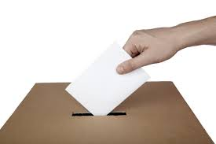
Federal Election 2015
Canadians share a deeply held

belief that access to health care
should not be based on how rich
we are, but on our medical need.

In this fall’s federal election,
please tell our politicians that
public health care matters. Help spread the word, by distributing election materials in your area.

Help protect & improve public health care for all!

To hand out election materials in your neighbourhood, at local seniors’ centres, workplaces, and throughout your community please fill in the order form here, then cut and return by mail to the OHC.

Due to new election rules, there are limits on advocacy organizations’ work. Materials must be distributed BEFORE the writ is dropped (that is when the election is formally called, likely in early September).

Postcard Voter Pledge Information Leaflet
Order Quantity:_______ Order Quantity:___________
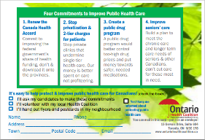
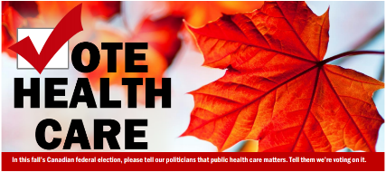

I can help distribute election materials, please send them to:
Name __________________________ Phone # ___________________
Address_________________________ Town_____________________
Postal Code ____________ Email ______________________________
You can find an order form online at: www.ontariohealthcoalition.ca

