Scarborough Liberal MPPs again promise to 'champion' hospital projects

Mitzie Hunter announces budget hike in pre-election speech
NEWS MAR 26, 2018 BY MIKE ADLER TORONTO.COM
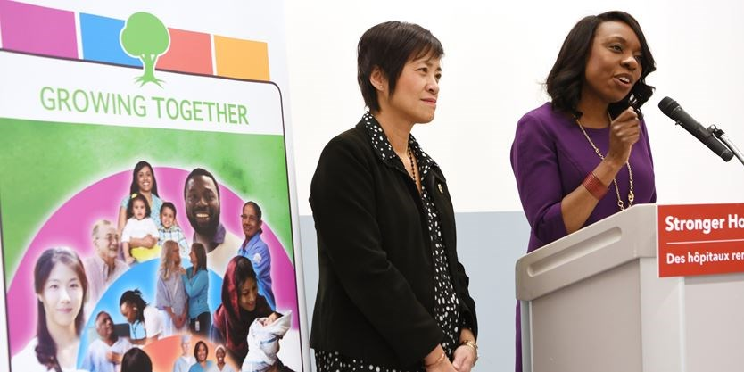
MPP Mitzie Hunter makes a funding announcement with MPP Soo Wong at the Scarborough and Rouge Hospital, General site Friday, March 23. - Dan Pearce/Metroland
In a pre-election speech, Scarborough-Guildwood MPP Mitzie Hunter stressed Ontario’s Liberal government and its five Scarborough MPPs “will champion” improvements to the area’s only acute-care hospital.
“We have to listen, and we listen to our communities,” Hunter told staff at Scarborough and Rouge Hospital’s General campus beside another Scarborough Liberal MPP, Soo Wong, on March 23.
“You have members that are fighting fiercely for you.”
Hunter’s announcement that there will be $9 million more in SRH’s budget for 2018 marked the third time in six months Liberals have come to the hospital pledging support.

Chinese community demands province invest in aging Scarborough hospitals

A month ago, Hunter said, she and Premier Kathleen Wynne were at SRH Centenary “to announce funding” for remaking the emergency room at that campus.
However, the premier didn’t do this. She didn’t commit the province to spend money for the ER’s construction, or say when it would start.
Wynne just said she supported a master planning exercise, launched last year, which should lead to a commitment to build.
Later on March 23, when asked to clarify, Hunter, minister of advanced education and skills development, confirmed this was what Wynne had done.
“It’s part of the master plan,” Hunter said. “Rebuilding the emergency department is part of the overall plan. What we announced was the government’s commitment to rebuilding the emergency department.”
Before he ordered the former Rouge Valley Health System to break up and its Centenary campus to merge with The Scarborough Hospital, Dr. Eric Hoskins, Ontario’s former health minister, appointed experts to tell the province what to do about acute care in Scarborough.
The panel told Hoskins to build a “comprehensive” new hospital campus in Scarborough, to remake ERs in Centenary and at SRH Birchmount, and to rebuild the General’s operating rooms, which are Ontario’s oldest and obsolete.
In April 2016, Hoskins endorsed all the recommendations, but apart from pledging $20 million to improve diagnostic suites at General, and a promise last year to spend an unspecified amount on the Bridletowne Community Hub, the government hasn’t committed itself to see any recommendation through to construction.
Asked whether replacement of the General’s ORs will start during the government’s next term, Hunter nodded. “We’ve done the hard work with the expert panel,” she said.
“This problem has to be fixed, and we’re going to fight for that for the people of Scarborough.”
Though SRH CEO Elizabeth Buller called Hunter and Wong “huge advocates for Scarborough and the hospital,” Kingsley Kwok of the Scarborough Health Coalition said residents are waiting for the government to say something about the Birchmount ER.
“It’s more than 30 years old. That’s one big thing the people of Scarborough are waiting for,” he said, adding the hospital is inundated with patients it can’t transfer to long-term-care because beds aren’t available.
The $9 million increase is larger than expected, said Kwok, but the province has cut back hospital funding so much over the last 20 years, “the government is realizing now they have to catch up.”
A provincial election is scheduled for June 7.

by Mike Adler
Mike Adler is a staff reporter for the Scarborough Mirror and InsideToronto. He can be reached at MAdler@insidetoronto.com. Follow

